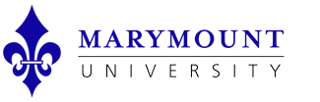
Events Request Form

For events or meetings organized/conducted by MU students, employees, departments, schools, colleges or student organizations, email completed forms to confcent@marymount.edu

Marymount Contact Name: | Contact Marymount ID # (if applicable):
Contact Phone: | Contact Email:
Event Title: | Event Purpose:
Event Date(s): | Event Start Time and End Time:
Estimated Number of Attendees (Internal): | Estimated Number of Attendees (External): Requires written VP prior approval. N/A
Space Requested (First Choice): | Space Requested (Second Choice):
Catering/Food Service Requests (requires Budget Code below):

Event Set Up Details:
No details.

Audio/Visual Needs (may result in additional charges): An Audio/Visual Technician can be present during your event for an additional charge.

Parking Needs (may result in additional charges):
Security Needs (may result in additional charges):
Other Special Arrangements:

Budget Code:

Events including one or more participants external to MU require VP written pre-approval.
FORMS SUBMITTED LESS THAN TWO WEEKS PRIOR TO DATE REQUESTED MAY NOT BE APPROVED.

